Homework #3 — Decision Tree, Naïve Bayes, and Validation
https://drive.google.com/file/d/1ijdUKu0IE7yIYywHkbg0RugitpOwQPVg/view?usp=sharing

This report covers both parts of Homework 3. Part 1 runs the decision tree sample code on the Pima diabetes data set, and Part 2 runs the Gaussian Naive Bayes sample code with the parameter changes. Everything was run in one Colab notebook, and the code and the output it produced are shown below.
Part 1 — Decision Tree Classifier (50 points)
The data file diabetes.csv is kept in my Google Drive folder for this course, so the notebook mounts the Drive first and reads the file from there.
In [1]:
from google.colab import drive
drive.mount('/content/drive') # diabetes.csv is kept in my Drive folder for this course

Out:
Mounted at /content/drive

The libraries are the four the sample code uses: pandas for the data frame, DecisionTreeClassifier for the model, train_test_split to divide the data, and the metrics module for the accuracy score.
In [2]:
# Load libraries
import pandas as pd
from sklearn.tree import DecisionTreeClassifier # Import Decision Tree Classifier
from sklearn.model_selection import train_test_split # Import train_test_split function
from sklearn import metrics # for the accuracy calculation

This is the one place where the sample code did not work as printed. The sample calls read_csv with header=None, which is correct for the original version of this file, but the diabetes.csv I was given already has a header row. With header=None that row is read in as a data row, every column then holds text instead of numbers, and the classifier fails with a conversion error later on. Using header=0 keeps the names= renaming while dropping the original header, which is the only change I made to the sample.
In [3]:
# Load dataset
col_names = ['pregnant', 'glucose', 'bp', 'skin', 'insulin', 'bmi', 'pedigree', 'age',
'label']

CSV = '/content/drive/MyDrive/BMEN6367/HW3/diabetes.csv'

# The sample code uses header=None, but the csv file I was given already has a header row.
# With header=None that row gets read in as data and every column ends up as text, which
makes
# the classifier fail later, so I use header=0 and let names= rename the columns instead.
pima = pd.read_csv(CSV, header=0, names=col_names)

print('rows, columns :', pima.shape)
pima.head()

Out:
rows, columns : (768, 9)
pregnant glucose bp skin insulin bmi pedigree age label
0 6 148 72 35 0 33.6 0.627 50 1
1 1 85 66 29 0 26.6 0.351 31 0
2 8 183 64 0 0 23.3 0.672 32 1
3 1 89 66 23 94 28.1 0.167 21 0
4 0 137 40 35 168 43.1 2.288 33 1

The data set loads as 768 rows and 9 columns, and head() shows the first five patients with the column names from col_names, so the file was read correctly.
Next the data frame is split into the feature matrix and the target. The seven features are the ones listed in the sample, and the label column is the diabetes outcome.
In [4]:
# Split dataset in features and target variable
feature_cols = ['pregnant', 'insulin', 'bmi', 'age', 'glucose', 'bp', 'pedigree']
X = pima[feature_cols] # Features
y = pima.label # Target variable

print('X shape :', X.shape)
print('y counts:', y.value_counts().to_dict()) # 0 = no diabetes, 1 = diabetes

Out:
X shape : (768, 7)
y counts: {0: 500, 1: 268}

The class counts show the data set is unbalanced: 500 patients without diabetes and 268 with it, so about 65 % of the samples are class 0. That matters when reading the accuracy further down, because always guessing "no diabetes" would already score about 65 %.
In [5]:
# Split dataset into training set and test set
X_train, X_test, y_train, y_test = train_test_split(X, y, test_size=0.3, random_state=1)
# 70% training and 30% test

print('training samples :', X_train.shape[0])
print('test samples :', X_test.shape[0])

Out:
training samples : 537
test samples : 231

The 70/30 split gives 537 training samples and 231 test samples. random_state=1 fixes the split so the same rows land in the same side every time the notebook is run.
In [6]:
# Create Decision Tree classifier object
clf = DecisionTreeClassifier()

# Train Decision Tree Classifier
clf = clf.fit(X_train, y_train)

# Predict the response for test dataset
y_pred = clf.predict(X_test)

# Model Accuracy, how often is the classifier correct?
print("Accuracy:", metrics.accuracy_score(y_test, y_pred))

Out:
Accuracy: 0.670995670995671

The classifier trains and predicts without any error, which is what this part of the assignment asks to demonstrate. The accuracy on the held out test set is 0.671, about 67 %. That is only a few points above the 65 % that guessing the majority class would give, and the reason is that DecisionTreeClassifier() with no arguments grows the tree until every leaf is pure. The tree ends up fitting the training rows almost perfectly and carries that noise into the test set, which is the classic overfitting behaviour of an unpruned tree. Limiting the depth or switching the split criterion would raise the test accuracy. One thing worth noting is that the number moves by a percent or so between runs: the tree still breaks ties between equally good splits at random, and no random_state is set on the classifier itself.
Part 2 — Gaussian Naïve Bayes Classifier (50 points)
For this part, there are two changes to the sample code: the number of features goes from 6 to 8, and the number of samples goes from 800 to 1200. Everything else — three classes, two informative features, one cluster per class and random_state=1 — is left as it was in the sample.
In [7]:
# Generating the Dataset
# The assignment asks for 8 features (instead of 6) and 1200 samples (instead of 800).
from sklearn.datasets import make_classification

X, y = make_classification(
n_features=8,
n_classes=3,
n_samples=1200,
n_informative=2,
random_state=1,
n_clusters_per_class=1,
)

print('X shape :', X.shape) # 1200 samples, 8 features
print('classes :', sorted(set(int(v) for v in y)))

Out:
X shape : (1200, 8)
classes : [0, 1, 2]

The generated matrix is 1200 × 8 with three classes, which confirms both parameter changes took effect.
In [8]:
# Visualize the dataset
import matplotlib.pyplot as plt

plt.scatter(X[:, 0], X[:, 1], c=y, marker="*")
plt.xlabel('feature 1')
plt.ylabel('feature 2')
plt.title('1200 samples, first two of the eight features')
plt.show()

Out:
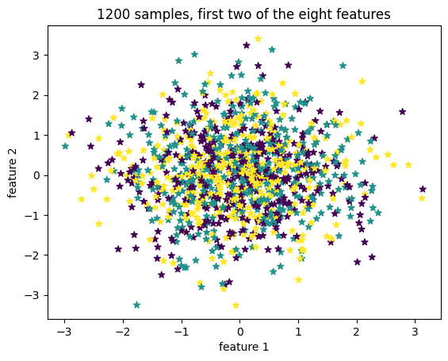

The scatter plot draws the first two of the eight columns. The three classes sit almost completely on top of each other, which looks wrong at first but is expected here: only two of the eight features are informative, and make_classification shuffles the columns, so columns 1 and 2 are not necessarily the two that carry the class information. The classifier does not have that problem because it sees all eight features at once. With the original six features the same plot was tighter, simply because the two informative columns had fewer uninformative ones to hide among.
In [9]:
# Split the dataset into train and test
from sklearn.model_selection import train_test_split

X_train, X_test, y_train, y_test = train_test_split(
X, y, test_size=0.33, random_state=125
)

print('training samples :', X_train.shape[0])
print('test samples :', X_test.shape[0])

Out:
training samples : 804
test samples : 396

The 33 % test split of 1200 samples gives 804 training and 396 test samples, up from 536 and 264 with the original 800 samples.
In [10]:
# Model Building and Training
from sklearn.naive_bayes import GaussianNB

# Build a Gaussian Classifier
model = GaussianNB()

# Model training
model.fit(X_train, y_train)

# Predict Output for one single test sample
predicted = model.predict([X_test[6]])

print("Actual Value:", y_test[6])
print("Predicted Value:", predicted[0])

Out:
Actual Value: 2
Predicted Value: 2

The model trains and then predicts a single test sample, the seventh one. The predicted class is 2 and the actual class is 2, so that individual prediction is correct.
In [11]:
# Model Evaluation
from sklearn.metrics import (
accuracy_score,
confusion_matrix,
ConfusionMatrixDisplay,
f1_score,
)

y_pred = model.predict(X_test)

accuray = accuracy_score(y_pred, y_test)
f1 = f1_score(y_pred, y_test, average="weighted")

print("Accuracy:", accuray)
print("F1 Score:", f1)

Out:
Accuracy: 0.8964646464646465
F1 Score: 0.8965355566018048

On the full test set the model scores an accuracy of 0.896 and a weighted F1 score of 0.897. The two being almost identical is a good sign: the F1 score weights precision and recall per class, so a large gap between it and the accuracy would mean one of the three classes was being handled much worse than the others.
In [12]:
# Visualize the Confusion matrix
labels = [0, 1, 2]
cm = confusion_matrix(y_test, y_pred, labels=labels)
disp = ConfusionMatrixDisplay(confusion_matrix=cm, display_labels=labels)
disp.plot()
plt.title('Gaussian Naive Bayes, 8 features / 1200 samples')
plt.show()

Out:
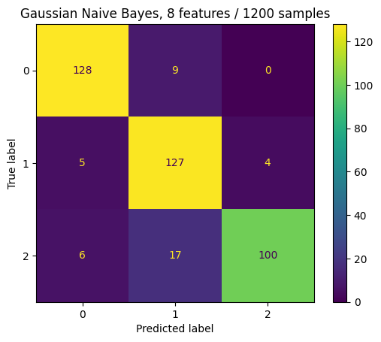

The confusion matrix shows where the mistakes are. Class 0 is almost perfect with 128 of 137 correct, class 1 gets 127 of 136, and class 2 is the weakest with 100 of 123 — most of its errors, 17 of them, are predicted as class 1. That single confusion between classes 1 and 2 accounts for a large part of the 41 misclassified samples out of 396. The result is consistent with the naive assumption the method makes: Gaussian Naive Bayes treats every feature as independent given the class, so two classes that overlap along the informative directions are the ones it mixes up.

